http://www.12sky2-ph.com/web/guide/start.aspx양식의 맨 위





[](http://www.12sky2-ph.com/)

**[news](http://www.12sky2-ph.com/web/news/announcement.aspx) Tin tức**

* [Announcements](http://www.12sky2-ph.com/web/news/announcement.aspx)
* [Notice](http://www.12sky2-ph.com/web/news/notice.aspx)

**[guide](http://www.12sky2-ph.com/web/guide/story.aspx) Hướng dẫn Game**

* [Story](http://www.12sky2-ph.com/web/guide/story.aspx)
* [Introduction](http://www.12sky2-ph.com/web/guide/Introduction.aspx)
* [Game Feature](http://www.12sky2-ph.com/web/guide/feature.aspx)
* [System Requirements](http://www.12sky2-ph.com/web/guide/requirements.aspx)
* [General Questions](http://www.12sky2-ph.com/web/guide/questions.aspx)
* [Getting Started](http://www.12sky2-ph.com/web/guide/start.aspx)
* [Class Info](http://www.12sky2-ph.com/web/guide/info.aspx)
* [Game Play](http://www.12sky2-ph.com/web/guide/play.aspx)
* [Pet Information](http://www.12sky2-ph.com/web/guide/pet.aspx)
* [Items](http://www.12sky2-ph.com/web/guide/item.aspx)
* [PvP Combat](http://www.12sky2-ph.com/web/guide/pvp.aspx)
* [Player Interaction](http://www.12sky2-ph.com/web/guide/player.aspx)
* [Government](http://www.12sky2-ph.com/web/guide/government.aspx)
* [NPCs](http://www.12sky2-ph.com/web/guide/npcs.aspx)

**[forums](http://www.12sky2-ph.com/web/community/list.aspx?DIV=discussion) Cộng đồng**

* [General Discussion](http://www.12sky2-ph.com/web/community/list.aspx?DIV=discussion)
* [Tips / Knowhow](http://www.12sky2-ph.com/web/community/list.aspx?DIV=tips)
* [Problem Solution](http://www.12sky2-ph.com/web/community/list.aspx?DIV=problem)
* [Item Trade](http://www.12sky2-ph.com/web/community/list.aspx?DIV=trade)

**[Media](http://www.12sky2-ph.com/web/media/video.aspx) Truyền thông**

* [Video](http://www.12sky2-ph.com/web/media/video.aspx)
* [Artwork](http://www.12sky2-ph.com/web/media/list.aspx?DIV=artwork)
* [Screenshots](http://www.12sky2-ph.com/web/media/list.aspx?DIV=screenshots)

**[Item Mall](http://www.12sky2-ph.com/web/shop/upgrading.aspx) Cửa hàng**

* [Item List](http://www.12sky2-ph.com/web/shop/upgrading.aspx)

**Game Guides**

* [Story](http://www.12sky2-ph.com/web/guide/story.aspx) Câu chuyện
* [Introduction](http://www.12sky2-ph.com/web/guide/introduction.aspx) Giới thiệu
* [Game Feature](http://www.12sky2-ph.com/web/guide/feature.aspx) Trò chơi tính năng
* [System Requirements](http://www.12sky2-ph.com/web/guide/requirements.aspx) Yêu cầu hệ thống
* [General Questions](http://www.12sky2-ph.com/web/guide/questions.aspx) Câu hỏi chung
* [**Getting Started**](http://www.12sky2-ph.com/web/guide/start.aspx) Bắt đầu
* [Class Info](http://www.12sky2-ph.com/web/guide/info.aspx) Thông tin các phe
* [Game Play](http://www.12sky2-ph.com/web/guide/play.aspx) Chơi game
* [Pet Information](http://www.12sky2-ph.com/web/guide/pet.aspx) Thông tin vật nuôi
* [Items](http://www.12sky2-ph.com/web/guide/item.aspx) Hạng mục
* [PvP Combat](http://www.12sky2-ph.com/web/guide/pvp.aspx) Chiến đấu PvP
* [Player Interaction](http://www.12sky2-ph.com/web/guide/player.aspx) Người chơi tương tác
* [Government](http://www.12sky2-ph.com/web/guide/government.aspx) Chính phủ
* [NPCs](http://www.12sky2-ph.com/web/guide/npcs.aspx) [NPCs](http://www.12sky2-ph.com/web/guide/npcs.aspx)

Home > Game Guides > Getting Started

Getting Started Bắt đầu

by SUPERManager 20 Aug 2013

INSTALLATION AND LOGIN Cài đặt và đăng nhập

* Welcome to TwelveSky2 WSP! Chào mừng bạn đến TwelveSky2 WSP!  
  You can begin by downloading the game here: TwelveSky2 WSP Download Page
* Bạn có thể bắt đầu bằng cách tải các trò chơi về ở đây: TwelveSky2 WSP Download Page
* 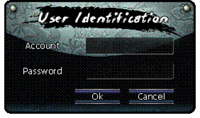
* - Logging In -
* Once you have downloaded and installed the game, you are ready to begin playing!
* Sau khi tải về và cài đặt các trò chơi, bạn sẵn sàng để bắt đầu chơi!
* Your 12sky2 WSP account is required for login. You can register a free account at [www.12sky2-ph.com](http://www.12sky2-ph.com).
* Bạn cần phải đăng nhập tải khoản 12sky2 WSP. Bạn có thể đăng ký một tài khoản miễn phí tại [www.12sky2-ph.com](http://www.12sky2-ph.com).
* Remember, accounts and passwords are case sensitive!
* Hãy nhớ, Tài khoản và mật khẩu của bạn bằng chữ in hoa hay chữ in thường!
* Character Creation Tạo nhân vật
* 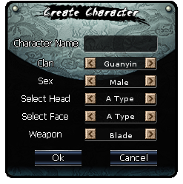
* There are several choices to make during character creation. You can customize your character's appearance, but you must also choose a Faction.
* Để tạo nên một nhân vật có mấy cách lựa chon sau đây. Bạn có thể tùy chỉnh diện mạo nhân vật của bạn, nhưng đồng thời bạn phải chọn một dảng phái(Faction)
* Each faction has different strengths and weaknesses, as well as different weapons. However, each faction has three types of weapons. While you select a weapon at this screen, you may also purchase and use a different weapon type once in game.
* Mỗi một phe đều có điểm mạnh và điểm yếu khác nhau, cũng như các loại vũ khí khác nhau. Tuy nhiên mỗi phe có ba loại vũ khí. Trong khi bạn chọn vũ khí ơ màn hình này, bạn vẫn có thể mua và sử dụng một loại vũ khí khác.
* 1. Offense - Greater attack power, but lower defense.
* 1. Tấn công – Sức mạnh tấn công mạnh, nhưng phòng thủ lại yếu.
* 2. Defense - Greater defense, but lower attack power.
* 2. Phòng thủ -Sự Phòng thủ mạnh, nhưng tấn công lại yếu
* 3. Ranged - Skills can be used at range.
* 3. Phạm vi - Skill có thể được sử dụng trong phạm vi

User Interface Dao diện người dùng

* 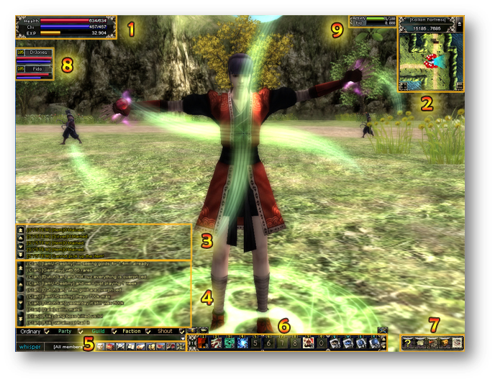
* 1. Player Status Window: Shows current Health, Chi, and Experience percent.
* 2. Zone Mini-Map: The mini-map shows current location, as well as NPC, quests, monsters, and party members. The map can be hidden with the arrow button, and zoomed in/out with the +/- keys.
* 3. System Messages: System messages will appear in this window. This includes Battle Grounds information, PvP and PvE damage/defense, as well as Guild system messages.
* 4. Player Chat: Chat from other players will appear in this window.
* 5. Mini Menu: The Mini Menu offers quick shortcuts to often-used windows, such as Character Stats, Inventory, Guild Info, etc.
* 6. Shortcut Bar: Skills, Pills/Tablets, and Emotes can be assigned to this bar, enabling the associated hotkey.
* 7. Quick Menu: Game Help can be opened with the ? button. There are also Faction-related windows available through this menu, as well as the Item Mall.
* 8. Party Information: Shows Party member levels, names, and HP/Chi status.
* 9. Pet Status Window: Shows Pet's Activity and Exp growth.

[top](http://www.12sky2-ph.com/web/guide/start.aspx)

KJ GAMESCopyright (c) KJ GAMES, All Rights Reserved.

* [Terms of Use](http://www.12sky2-ph.com/web/about/terms.aspx)
* [Privacy Policy](http://www.12sky2-ph.com/web/about/privacy.aspx)

양식의 맨 아래